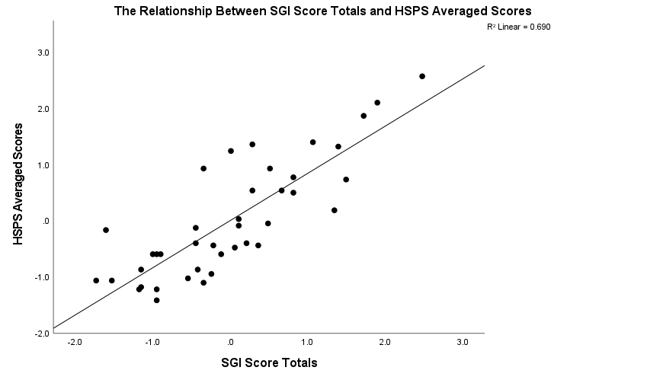

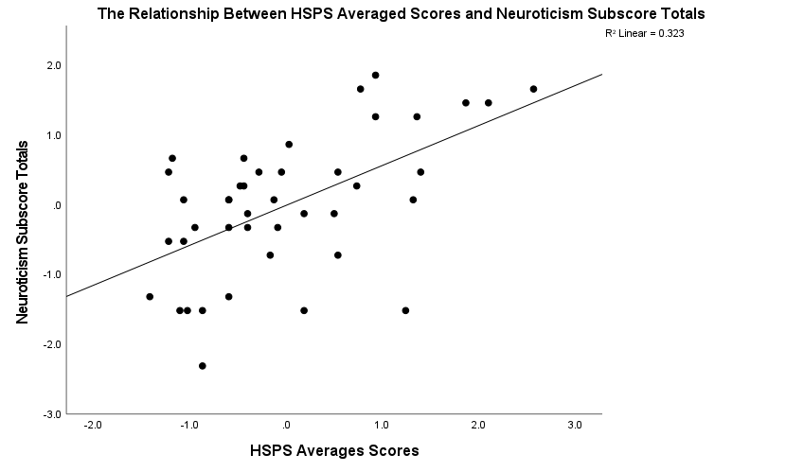

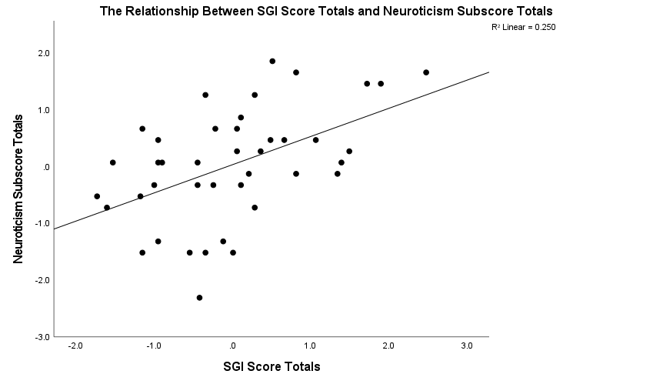

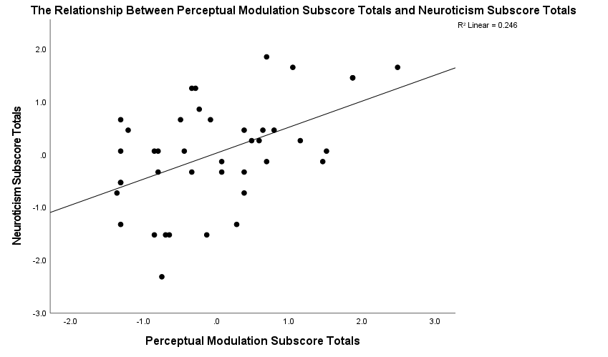

|  |  |  |  |  |  |  |
| --- | --- | --- | --- | --- | --- | --- |
| **Correlations** | | | | | | |
|  | | Zscore(HSPS_Average) | Zscore(P1) | Zscore(P2) | Zscore(P4) | Zscore(P11) |
| Zscore(HSPS_Average) | Pearson Correlation | 1 | .642** | .806** | .798** | .558** |
| Sig. (2-tailed) |  | .000 | .000 | .000 | .000 |
| N | 42 | 36 | 36 | 36 | 36 |
| Zscore(P1) | Pearson Correlation | .642** | 1 | .745** | .734** | .414* |
| Sig. (2-tailed) | .000 |  | .000 | .000 | .011 |
| N | 36 | 37 | 37 | 37 | 37 |
| Zscore(P2) | Pearson Correlation | .806** | .745** | 1 | .777** | .614** |
| Sig. (2-tailed) | .000 | .000 |  | .000 | .000 |
| N | 36 | 37 | 37 | 37 | 37 |
| Zscore(P4) | Pearson Correlation | .798** | .734** | .777** | 1 | .576** |
| Sig. (2-tailed) | .000 | .000 | .000 |  | .000 |
| N | 36 | 37 | 37 | 37 | 37 |
| Zscore(P11) | Pearson Correlation | .558** | .414* | .614** | .576** | 1 |
| Sig. (2-tailed) | .000 | .011 | .000 | .000 |  |
| N | 36 | 37 | 37 | 37 | 37 |
| **. Correlation is significant at the 0.01 level (2-tailed). | | | | | | |
| *. Correlation is significant at the 0.05 level (2-tailed). | | | | | | |